|  |  |  |
| --- | --- | --- |
|  | **Functional Test** | **Non Fuctional Test** |
| **Notepad** | Verify that the user can type numerics from a standard keyboard.  Verify that the user can close the editor window by clicking the close icon. | We have to check that when we save file with name, same name display in open box.  We type a something on notepad entire contain must be shown in same font style and size. |
| **Face Book** | When we are upload the picture on facebook at that time we get proper result such as same picture show on profile which we actual uploaded.  When we send the friend request to friends, at that time request must be shown to our friends only. | Facebook application properly run on all system such as ios and android. Different browser we get the same result and same function of the face book.  At a same moment more than millons of user using facebook than facebook run smoothly. |

**2. What is SRS ? (Software Requirements Specification)**

A software requirements specification (SRS) is a document that describes what the software will do and how it will be expected to perform. It also describes the functionality the product needs to fulfill all stakeholders (business, users) needs.

An SRS forms the basis of an organization’s entire project. It sets out the framework that all the development teams will follow. It provides critical information to all the teams, including development, operations, quality assurance (QA) and maintenance, ensuring the teams are in agreement.

**3. What is OOPS?**

Object-oriented programming (OOP) is a computer programming model that organizes software design around data, or objects, rather than functions and logic. An object can be defined as a data field that has unique attributes and behavior.

**4. What is SDLC?**

The Software Development Life Cycle (SDLC) is a structured process that enables the production of high-quality, low-cost software, in the shortest possible production time. The goal of the SDLC is to produce superior software that meets and exceeds all customer expectations and demands.

**5. Write basic concept of oops?**

* CLASS
* OBJECTS
* ENCAPSULATION
* POLYMORPHISM
* INHERITANCE
* ABSTRACTION

**6. What is object?**

A data set and the functions that affect it are contained within an object.

An object consists of:

**1. Name = the variable name we give it**

**2. Member data** = the data that describes the object

**3. Member functions** = behavior aspects of the object (functions related to the object itself).

**7. What is class?**

Class testing is the base of object-oriented software testing. It involves three aspects: testing each method, testing the relations among class methods and testing the inheriting relation between class and subclass.

**8. What is encapsulation?**

Encapsulation is a fundamental notion in OOP, and it refers to hiding the internal state and functions of an object, as well as binding the code and the data it manipulates under the same unit. It is used to restrict the direct access to some of the object's components.

**9. What is inheritance ?**

The process through which objects of one class acquire the characteristics of objects of another class is known as inheritance.

1. **Single Inheritance**

In single inheritance, a class derives from one base class only. This means that there is only one subclass that is derived from one superclass.

1. **Multiple Inheritance**

Multiple inheritance is a type of inheritance in which a class derives from more than one classes.

**3) Multilevel Inheritance**

In multilevel inheritance, a class is derived from another derived class. This inheritance can have as many levels as long as our implementation doesn’t go wayward.

**4) Hybrid Inheritance**

Hybrid inheritance is usually a combination of more than one type of inheritance.

**5) Hierarchical Inheritance**

This is where one class serves as a superclass (base class) for more than one sub class.

**10. What is polymorphism ?**

The word “polymorphism” means having many forms. In simple words, we can define polymorphism as the ability of a message to be displayed in more than one form.

**11. What is RDBMS ?**

RDBMS stands for Relational Database Management System.

RDBMS is a program used to maintain a relational database.

RDBMS is the basis for all modern database systems such as MySQL, Microsoft SQL Server, Oracle, and Microsoft Access.

**12. What is SQL?**

**SQL** (pronounced "ess-que-el") stands for Structured Query Language. SQL is used to communicate with a database. According to ANSI (American National Standards Institute), it is the standard language for relational database management systems.

**13. Write SQL Commands?**

Four type of SQL commands are there

**Data Definition Language (DDL)** – Consists of commands which are used to define the database.

**Data Manipulation Language (DML)** **–** Consists of commands which are used to manipulate the data present in the database.

**Data Control Language (DCL) –** Consists of commands which deal with the user permissions and controls of the database system.

**Transaction Control Language (TCL)** – Consist of commands which deal with the transaction of the database.

**14. Draw Use case on online book shopping**

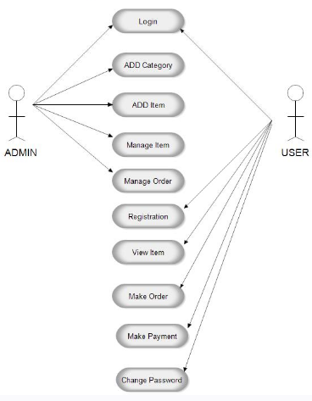

**15. Draw Use case on online bill payment system (Paytm)**

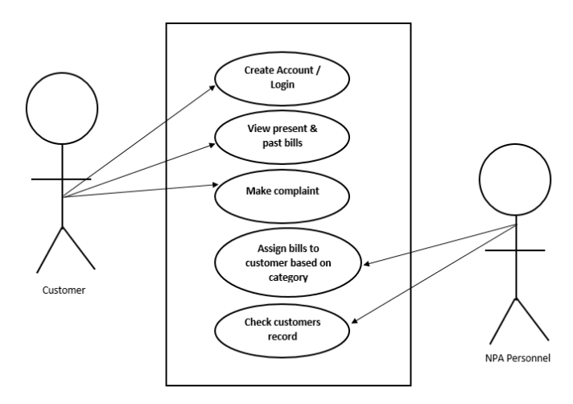

**16. Write SDLC phases with basic introduction?**

Software Development Life Cycle is the application of standard business practices to building software applications. It’s typically divided into six steps: **Requirement, Design, Implementation, Testing, Deployment, and Maintenance.**

**1. Requirement:** In this phase, all the requirements are collected from the customer/client. They are provided in a document called Businessmen requirement specification (BRS) and System requirement specification (SRS). All the details are discussed with the customer/client in detail.

**2. Design: It has two steps:**

High-level design (HLD): It gives the architecture of software products.

Low-level design (LLD): It describes how each and every feature in the product should work and every component.

**3. Implementation:**

This is the longest phase.

This phase consists of Front end + Middleware + Back-end.

In front-end: Development of coding is done even SEO settings are done.

In Middleware: They connect both the front end and back end.

In the back-end: A database is created.

**4. Testing:** Testing is carried out to verify the entire system. The aim of the tester is to find out the gaps and defects within the system and also to check whether the system is running according to the requirement of the customer/client.

**5. Deployment:** After successful testing, the product is delivered/deployed to the client, and even clients are trained on how to use the product.

**6. Maintenance:** Once the product has been delivered to the client a task of maintenance starts as when the client will come up with an error the issue should be fixed from time to time.

**17. Explain Phases of the waterfall model**

Waterfall approach was first SDLC Model to be used widely in Software Engineering to ensure success of the project. In "The Waterfall" approach, the whole process of software development is divided into separate phases. In this Waterfall model, typically, the outcome of one phase acts as the input for the next phase sequentially.

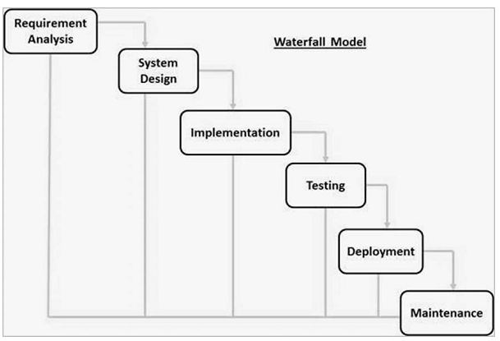

**Requirement Gathering and analysis −** All possible requirements of the system to be developed are captured in this phase and documented in a requirement specification document.

**System Design −** the requirement specifications from first phase are studied in this phase and the system design is prepared. This system design helps in specifying hardware and system requirements and helps in defining the overall system architecture

**Implementation −** with inputs from the system design, the system is first developed in small programs called units, which are integrated in the next phase. Each unit is developed and tested for its functionality, which is referred to as Unit Testing.

**Integration and Testing −** All the units developed in the implementation phase are integrated into a system after testing of each unit. Post integration the entire system is tested for any faults and failures.

**Deployment of system −** Once the functional and non-functional testing is done; the product is deployed in the customer environment or released into the market**.**

**Maintenance −** There are some issues which come up in the client environment. To fix those issues, patches are released. Also to enhance the product some better versions are released. Maintenance is done to deliver these changes in the customer environment.

|  |  |
| --- | --- |
| **Advantages** | **Disadvantages** |
| Easy to understand & functional | Risky and uncertain |
| Simple enough to manage | Lack of visibility of current progress |
| Allows for easy testing and analysis | Very short of flexibility |
| Save significant amount of time | Cant edit in testing phase |

**18. Write phases of spiral model.**

The spiral model combines the idea of iterative development with the systematic, controlled aspects of the waterfall model. This Spiral model is a combination of iterative development process model and sequential linear development model so that the waterfall model with a very high emphasis on risk analysis. It allows incremental releases of the product or incremental refinement through each iteration around the spiral.

The spiral model has four phases. A software project repeatedly passes through these phases in iterations called Spirals.

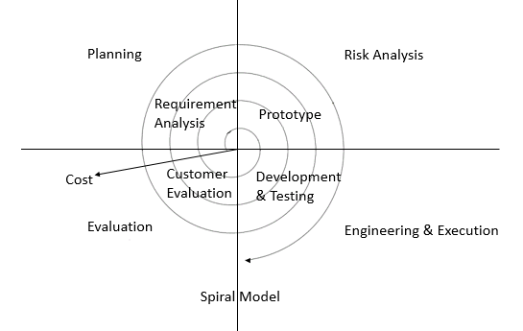

|  |  |
| --- | --- |
| **Advantages** | **Disadvantages** |
| Risk handling | Complex |
| Large projects | Expensive |
| Flexible | Too much risk analysis |
| Customer satisfaction | Time consumption |

**19. What is join?**

SQL Join statement is used to combine data or rows from two or more tables based on a common field between them. Different types of Joins are as follows:

**1. Inner join**

The INNER JOIN keyword selects all rows from both the tables as long as the condition is satisfied. This keyword will create the result-set by combining all rows from both the tables where the condition satisfies i.e value of the common field will be the same.

**2. Left join**

This join returns all the rows of the table on the left side of the join and matches rows for the table on the right side of the join. For the rows for which there is no matching row on the right side, the result-set will contain null. LEFT JOIN is also known as LEFT OUTER JOIN.

**3. Right join**

This join returns all the rows of the table on the right side of the join and matching rows for the table on the left side of the join. For the rows for which there is no matching row on the left side, the result-set will contain null. RIGHT JOIN is also known as RIGHT OUTER JOIN.

**4. Full join**

FULL JOIN creates the result-set by combining results of both LEFT JOIN and RIGHT JOIN. The result-set will contain all the rows from both tables. For the rows for which there is no matching, the result-set will contain NULL values.

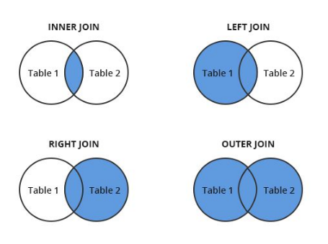

**20. Draw usecase on Online shopping product using payment gateway.**

